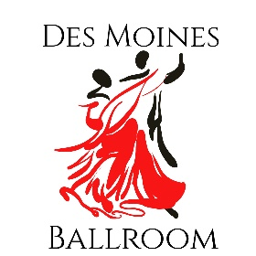
DAY OF DANCE
May 6, 2023
Entry Form
Name___________________________________
Tickets
Full Day $80/70
Master Class 1 $20/15
Master Class 2 $20/15
Master Class 3 $20/15
Master Class 4 $20/15
Evening Ticket $20/15
Showcase Performance $50
Jack and Jill Passport $20
J&J Mystery Dance $5
J&J Salsa $5
J&J Swing $5
J & J Theme $5
J&J Same Sex $5
J&J 3 Person $5
J&J Reverse Lead $5
Total

Showcase
#1 Song___________________________________________ Style________________________
Lead____________________________________ Follow___________________________________
Choreographer_____________________________________________
#2 Song___________________________________________ Style________________________
Lead____________________________________ Follow___________________________________
Choreographer_____________________________________________
Make Checks Payable to Des Moines Ballroom and Send to Des Moines Ballroom * c/o Day of Dance *1925 High Street * Des Moines, IA 50309
Please send your questions to annelbates@yahoo.com or call at 515-402-5594

