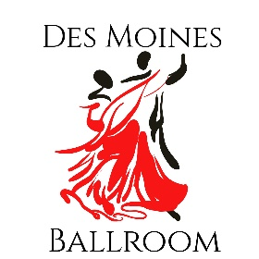
DAY OF DANCE
May 6, 2023

Location
Master Classes Showcases/Jack and Jills Grandview University
Des Moines Ballroom Johnston Wellness Center
1925 High Street 1500 Morton Ave
Des Moines, IA 50309 Des Moines, IA 50316

Schedule
1-1:50 Master Class 1 with Tallis Strub
2-2:50 Master Class 2 with Gordan and Kate Bratt
3-3:50 Master Class 3 with Gordan and Kate Bratt
4-4:50 Master Class 4 with Gordan and Kate Bratt
6:00 – Showcase warm-ups
7:00-10:00 Showcases, Jack and Jill Dances, and General Dancing

Pricing
Full Day (4 workshops, showcase) $80/adult $70/student
Master Classes (Individual) $20/adult
$15/student
Evening Event $20/adult
$15/student
Showcase Performance $50
Jack and Jill Passport (unlimited entries) $20
Jack and Jill $5/entry

Please send your questions to annelbates@yahoo.com or call at 515-402-5594

