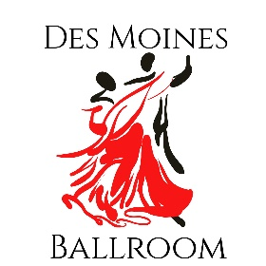
DAY OF DANCE
May 6, 2023

Information
Welcome to the 6th annual Day of Dance. The premier event for improving your dance technique and performing in showcases. The event will be held at:
Master Classes Showcases and Jack and Jills
Des Moines Ballroom Grandview University
1925 High Street Johnston Wellness Center
Des Moines, IA 50309 1500 Morton Ave
Des Moines, IA 50316

This event will feature an amazing afternoon of Master Classes by the talented Gordan Bratt, Kate Bratt, and Tallis Strub. The evening will consist of showcase performances, Jack and Jill events, and general dancing. Deadline for showcase performance entry is 4/21/23. Showcases will be critiqued by a panel of judges. Jack and Jill Passports allow you to enter as many or as few jack and jill events as you would like saving you money!
Workshops
1-1:50 Balancing Body and Control Tallis Strub
2-2:50 Elements of Style in Smooth Dancing Kate Bratt/Gordan Bratt

3-3:50 Variations on a Crossover Break Kate Bratt/Gordan Bratt

4-4:50 Salsa Shines Kate Bratt/Gordan Bratt

Please send your questions to annelbates@yahoo.com or call at 515-402-5594

